1. Getting to MacDill Air Force Base
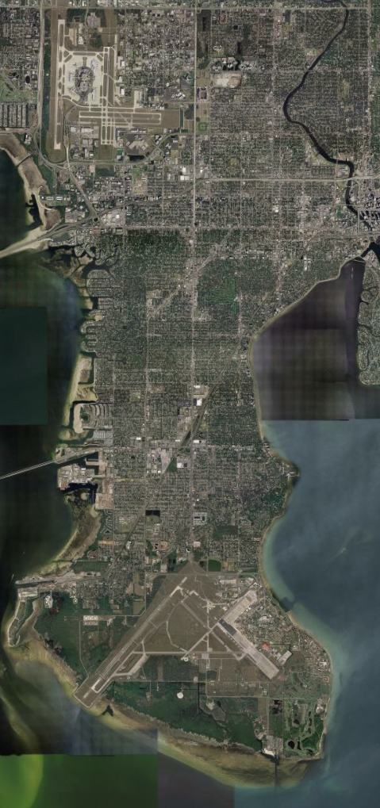

Tampa
International
Airport
MacDill
Air Force Base

• Exit the airport

• Follow signs to Kennedy,
eastbound

• Turn right on Dale Mabry
MacDill Visitors’ Center
is at end of Dale Mabry

2. Getting onto base

A). NOAA ID holders:

Present your current NOAA ID at the security checkpoint at any base entrance; a separate base pass is not required. If driving a rental vehicle, present the rental agreement along with your current NOAA ID at the gate. A separate vehicle tag is not required for rental vehicles driven by NOAA-badged drivers.

B). Everyone else:

The first time you come on base, stop at the MacDill Visitor’s Center at the Dale Mabry gate to obtain a USAF MacDill base pass (and a separate vehicle tag, if you have a rental vehicle). You will need to present a current NOAA permission letter and a standard picture ID (valid driver’s license, passport, etc.). Permission letters will be provided by the AIC to each visitor in advance of their first visit to MacDill. Visitor’s Center hours of operation are
Sunday and Monday: 6 AM to 10:45 PM
Tuesday through Saturday: 6 AM to midnight

The NOAA permission letters expire 10 days after their date of issue; please verify that the permission letter will not have expired when you first intend to come onto base. Once obtained from the Visitors’ Center, the USAF base pass dates should cover the entire project duration, including de-installation at the end; please check the dates printed on your base pass before leaving the Center. Once you have obtained a USAF base pass (and rental vehicle tag, if necessary), you can proceed directly to the security checkpoint at any base entrance thereafter.

PLEASE NOTE that rental vehicle tags are matched to specific license plates; if you change cars, you will need to stop at the Visitors’ Center again with your USAF base pass and new rental car agreement to get a new pass for your new vehicle.

WHAT TO DO IF THESE PROCEDURES DO NOT WORK FOR YOU

Please call one of the following phone numbers, in the order listed, for assistance in getting through the gate.

• Dr. Jim McFadden – AOC Project Manager 813-833-1734 (cell)
813-828-3310 x3076 (office)

• Ed Kosciuch – CSD project contact 720-226-2155 (cell; call any time)
303-497-4218 (office)

• Janie Wilson – AOC Admin. Assist. 813-385-1042 (cell)
(call Janie from 8 AM to 4:30 PM ONLY) 813-828-3310 x3036 (office)

Please note that procedures for getting onto MacDill can change without notice, so please be understanding of base security needs if things don’t go exactly according to plan. We try hard to minimize the difficulty of working on an active military airfield, but surprises always crop up. Your patience will usually be rewarded with only a short delay in getting onto base.

3. Getting to the NOAA AOC hangar

From the Dale Mabry gate, continue on the main base road for about a mile until you see signs for Hangar Loop Drive or “Hangars 1-5”; follow these until you begin to pass hangars on your right. The NOAA facilities are located in Hangar #5, the last of the five on Hangar Loop Drive.

To minimize any misunderstandings with base security personnel, please
- do not exceed the speed limit on base;
- do not use your cell phone while driving on base;
- do not photograph anything outside of the NOAA hangar.

